Optimization of Digital Holography with Deep Learning for Non-Destructive Surface Defect Detection from Photovoltaic Cell
Abdullahi Bako¹, Suebtarkul Suchat² and Prathan Buranasiri^{1*}
¹Artificial Intelligence Photonics Advanced Research Laboratory, Department of Physics, School of Science, King Mongkut’s Institute of Technology, Ladkrabang, Bangkok 10520, Thailand.
²Faculty of Science and Technology, Phranakhon Rajahat University, Bangkok 10220 Thailand.
Corresponding author: *prathan.bu@kmitl.ac.th
Abstract
Digital holography (DH) is an imaging technique that records the wavefront of an object, enabling reconstruction of both 3D, quantitative phase and intensity images through computational algorithms. Traditional analysis techniques often have limitations, including the need for electrical connections, a lack of automation, and difficulties in interpreting complex surface defects. This paper proposes a digital holography technique aligned with a deep learning approach using the YOLOv8 model to identify defects in PV cells. A dataset of 800 reconstructed DH images was annotated and used for training via the Roboflow platform. Surface roughness was clearly detected, enabling precise differentiation of defective regions. Overall, the hierarchical digital holography-based inspection framework provides a reliable and scalable alternative to conventional photovoltaic diagnostic techniques, enabling accurate, non-contact defect assessment for both laboratory and industrial applications compared to traditional methods, such as electroluminescence (EL), photoluminescence (PL), atomic force microscopy (AFM), profilometry, and infrared thermography imaging in controlled PV testing environments.
Keywords: - Digital holography, photovoltaic cell, surface defect classification, deep learning, YOLOv8, CNN architecture.
- Introduction
Deep learning is a branch of machine learning and has become a potent instrument for intricate image analysis [1]. Among its various architectures, convolutional neural networks (CNNs) have shown strength in detecting subtle visual patterns that may be imperceptible to the human eye [2, 24-28]. These models process images in milliseconds when accelerated by GPUs, making them ideal for applications that require real-time processing, such as digital holography [2]. In practice, convolutional neural networks (CNNs) have demonstrated high effectiveness in managing noisy and complex data often encountered in digital holography systems. Previous work by [3] proposed a CNN-based approach to retrieve only phase information from complex multi-plane holograms, and their method improved reconstruction quality significantly by leveraging diverse datasets and a combination strategy, enabling generalization across a range of image types without requiring object-specific training. Similarly, recurrent neural networks (RNNs) have been applied to phase estimation tasks, providing robust results even in the presence of heavy noise and corrupted fringe data, as demonstrated through numerical simulations [1–4]. Another deep learning strategy aimed at reducing speckle noise in holographic images was reported in [5], further supporting the role of AI-driven methods in enhancing holographic imaging. Digital holography, by definition, involves recording the object’s wavefront on a digital sensor, followed by a computational algorithm to yield both 3D and quantitative phase information [6–8]. This makes it well-suited particularly for non-destructive inspection tasks compared to conventional inspection methods, such as electroluminescence (EL), photoluminescence (PL), atomic force microscope (AFM), profilometry, and infrared thermography, which often come with limitations, typically lack automation for detecting surface-level defects under controlled lab conditions, and usually depend on costly specialized equipment. However, Random Forests (RF) and Support Vector Machines (SVM) have also been applied in photovoltaic (PV) fault diagnosis for analyzing electroluminescence (EL) images to detect defects in solar modules using a machine learning approach [9, 10]. The growing global demand for clean and sustainable energy has made photovoltaic (PV) technology increasingly vital, driving the need for more efficient and accurate diagnostic methods from the manufacturing industry [11]. Propelled by the boundless potential of solar energy [12], the need for accurate, scalable, and non-invasive diagnostic tools becomes increasingly important. Defects such as surface micro-cracks, scratches, surface roughness, dust, and other particulate contamination can significantly affect efficiency [13], lifespan [14], and overall module quality [15, 16]. Thus, to overcome challenges related to electrical contact and time constraints in photovoltaic (PV) inspection. [17] have explored the use of shape-tailored laser sources for inducing photoluminescence (PL) and electroluminescence (EL) at the module level, and technical advancements in this area have shown promising results. These methods can identify more defects than traditional EL techniques, especially when integrated with approaches such as black silicon (black-Si) testing [18, 30], and indicate a bright region in laser line-induced luminescence as a strong signal for PL line scan data as indicated in [44]. These findings support the adoption of digital holography as a practical alternative or complement to conventional photovoltaic inspection methods. Capturing the optical wavefront through coherent laser illumination and reconstructing both phase and intensity images using a computational algorithm also provides a distinct, non-contact approach for identifying defects in PV modules.
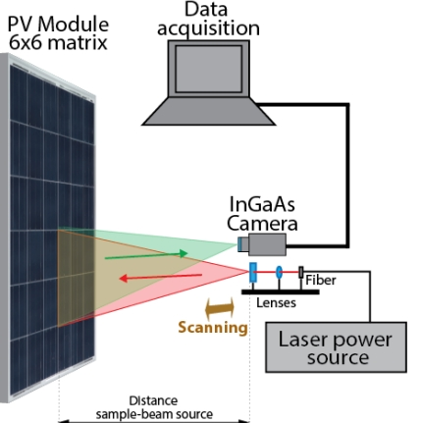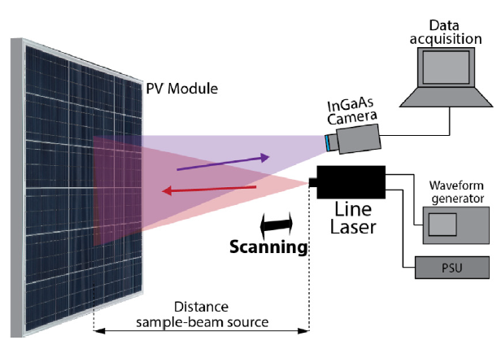
Fig.1. PL laser line scan Experimental setup reprinted from [17].
Fig.2. Experimental setup reproduced with Reference [44].

  - Digital Holography Theory
Holographic imaging offers unique capabilities not available in other optical methods, serving as a non-contact, high-resolution approach that captures both 3D, phase, and amplitude information of a semiconductor wafer [19-31, 43]. The use of digital holography provides a controlled environment that enables precise inspection and defect analysis, making it highly suitable for photovoltaic research and diagnostics conducted in laboratory settings. These approaches typically struggle to extract meaningful features from complex or noise-affected dataset conditions. Recent advancements in experimental setups and computational methodologies have substantially enhanced the performance and robustness of digital holography [19]. Beyond its traditional roles in physics and engineering, the technique has increasingly been adopted in biomedical imaging, where accurate phase retrieval is essential for quantitative analysis [20]. In a typical digital holography system. A coherent laser source is separated into the object beam and the reference beam by means of a beamsplitter. These two beams overlap and create an interference pattern based on their phase and amplitude differences, indicated in the schematic and experimental setup diagrams, Fig. (3 & 4). The interference results between the reference wave and object wave with its own complex amplitude, and this interference encodes the full optical field of the object, which can be numerically reconstructed to yield both 2D and 3D representations. However, a schematic of the optical setup and the corresponding experimental arrangement illustrates the complex amplitude produced when the reference wave and object wave interfere, which has the following mathematical expression:
$O\left(p,q\right) =B_{o} \left(p, q\right)e^{-i∅_{o}\left(p ,q\right)}$ (1)
$R\left(p,q\right) =B_{R} \left(p, q\right)e^{-i∅_{R}\left(p ,q\right)}$ (2)
Where O stands for the objective beam, R for the Reference beam, Bo for the Amplitude of the object, and B_{R} for the Amplitude of the reference wave. $∅$_{o} represents the Phase of the object Wave,$and ∅$_{R} represents the Phase of the reference wave.
Thus, the interference creates a hologram as H$\left(p, q\right)$, and can be written as
$H\left(p, q\right) = {\left|O\left(p, q\right) + R\left(p,q\right)\right|}^{2}$ (3)
Expanding [Eq. (3)] yield
$H\left(p, q\right) = {\left|R\left(p, q\right)\right|}^{2} + {\left|O\left(p, q\right)\right|}^{2 }+ R^{*}\left(p,q\right)O\left(p,q\right) + R\left(p,q\right)O^{*}\left(p,q\right)$ (4)
The term * represents the conjugate, where (p, q) indicate the horizontal and vertical dimensions. The interference that explains the object's reconstruction is represented by the first two words, as later [19–21, 30].
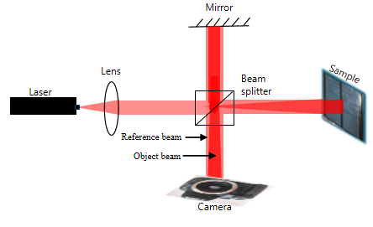
Fig. 3 The schematic Diagram of Digital Holography
This work presents an innovative framework that combines deep learning with digital holography to detect and classify surface defects on photovoltaic (PV) cells under controlled conditions (indoor). The proposed approach enhances inspection accuracy through high-resolution, non-contact imaging and eliminates the need for electrical connections. Various digital holography methods for defect detection were discussed. Integration enables the real-time identification of faults and contributes to the development of intelligent quality assurance systems in PV research and manufacturing. Moreover, the results not only align with deep learning but also outperform detection compared with [30], exhibiting broader defect coverage and uncovering additional flaw regions that were not previously identified.

2.0 Materials and Methods
2.1 Materials
The materials and tools depicted in the schematic diagram are a laser diode, objective lens, beamsplitter, solar module, mirror, and CCD camera, which were utilized and assembled as shown in the experimental setup diagram, Fig. 4. However, a clear pattern emerges in which the defects accumulate along one side of the solar cell. But, not visible through direct visual observation, when focused on Fig. 5.
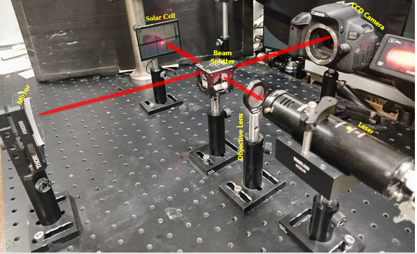
Fig.5. Solar Cell
Fig.4. Experimental Setup
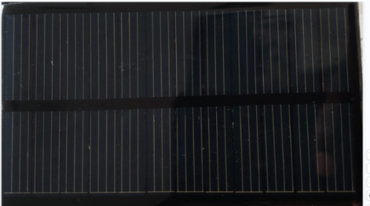
2.2 Methodology
An inline digital holography setup was adopted, and a coherent laser acts as the primary light source. The laser beam passes through an objective lens and enters a beamsplitter, where it is separated into two paths: the reference beam and the object beam. The beam of the object illuminates the surface of the photovoltaic (PV) cell and reflects toward the beamsplitter. Simultaneously, the reference beam points in the direction of a mirror and is reflected in the beamsplitter, where it overlaps with the object beam to produce an interference pattern. Two key phenomena were observed during the process: Newton’s rings and energy is redistributed due to the interference between the reference beam and object beam, where constructive and destructive interference occur in line with the concept principle of superposition and conservation of energy. The resulting interference patterns encode essential phase and amplitude information from the sample surface. A CCD camera recorded the hologram, which was subsequently reconstructed numerically using computational techniques to retrieve the optical field, and the reconstructed data were then processed and used as input for the machine learning model.
2.3 Machine Learning
Machine learning, particularly artificial intelligence-based classification, has shown considerable potential in automating the analysis of microscopic image data [22-32]. Prior studies have successfully used compact interferometric setups to extract morphological features from biological cells, enabling the classification of red blood cells (RBCs) in good health and sickness [22, 23]. Deep learning techniques, precisely convolutional neural networks (CNNs), were used to identify and highlight defects on photovoltaic surfaces with high accuracy and efficiency. CNNs are well-suited for recognizing patterns and spatial irregularities in complex image datasets produced by digital holography [23, 24]. Deep learning has been widely applied in other imaging fields [19-25]. Recent advancements have shown that convolutional neural network (CNN) architectures are capable of effectively denoising interferometric digital holography images, even when access to high-quality, noise-free training data is limited [25, 26]. Manual inspection of such holograms is time-consuming and often inconsistent, highlighting the need for automated segmentation algorithms as a necessary advancement [19]. Our approach, holographic image data, and corresponding annotated targets were fed into the network architecture, which is schematically presented in Figs. (6 & 7). These illustrate the reconstruction workflow and network structure used to achieve robust defect classification and visualization.
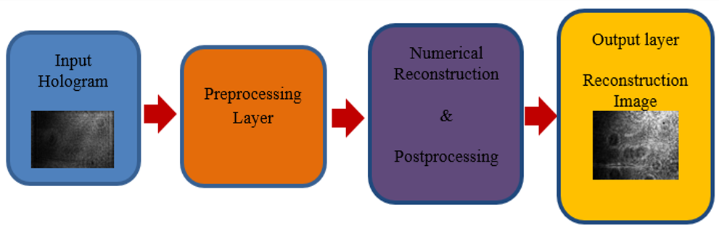
Fig. 6. Reconstructed structure

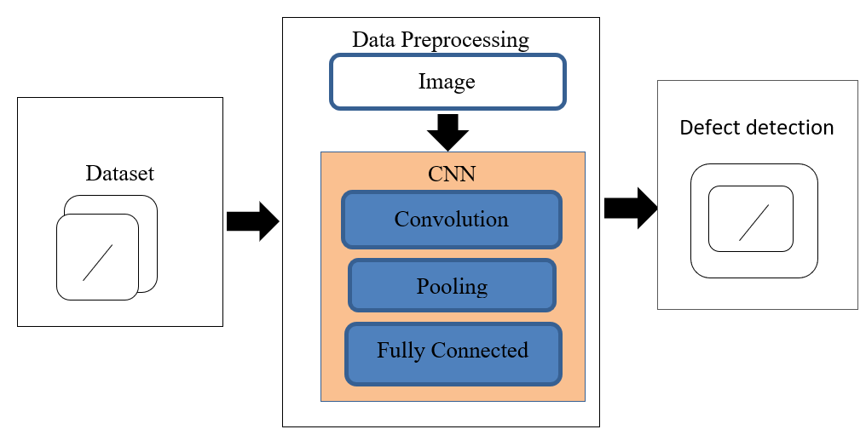
Fig 7. Network structure

2.3.1 CNN-Based Defect Detection in Solar Panel Using YOLOv8
Convolutional Neural Networks (CNNs) are a group of algorithms for deep learning, well-suited for interpreting visual data [19, 28]. A deep learning and image processing technology, YOLO models are increasingly utilized for real-time object recognition [33], and high precision as well as lightning-fast processing speed make them extremely popular in domains such as security cameras, self-driving cars, and medical assistance [34]. Roboflow platform streamlines data preprocessing, applies augmentation techniques, and manages the training pipeline efficiently [28-34]. For this application, a cutting-edge object recognition framework called YOLOv8 was selected due to its proven performance in real-time image classification tasks, enabling accurate detection and identification of surface defects. The training dataset was manually annotated and enhanced through several augmentation methods that enhanced generalization, including rotation, flipping, and brightness variation. Previous studies, including the development of HoloConvNet [28], have demonstrated that CNNs are highly effective in analyzing quantitative phase images of biological samples [29]. However, the Google Colab cloud platform, which offers a potent GPU tool that doesn't require any setup, was used to train the model in [30-42], and built on the training using YOLOv3, YOLOv5, and YOLOv8 architectures, all utilizing pretrained COCO weights to enhance performance. Three subsets of the annotated data set of 800 images were created. 11% (88 images) for testing, 19% (152 images) for validation, and 70% (560 images) for training the data. The training process took approximately 56 minutes to complete the model, based on the architecture in Fig. 8. Similarly, the input data from Roboflow was annotated, and all the data was approved based on validation test training. The model was run on the test workflow and then on the input. The object detection model is then separated into two distinct, boundary box visualizations and property definition, which overlap with the level visualization to produce a custom result.
Custom Dataset
(Images)
Reconstructed Hologram Images

Validation (19%)
(156 Images)
Testing (11%)
(88 Images)
Trainings (70%)
(560 Images)
YOLOv8 Model
(CNN-Based)

Generation of Trained
Weights

Image Inference
(Detection on new images)

Fig. 8. CNN-Based Defect Detection framework using YOLOv8 Architecture

The reconstructed holographic images are depicted in the above architecture using a YOLOv8, CNN-based approach to identify the flaws. A labeled data set is used to train and validate the model; the testing step assesses how well the trained model performs on data that hasn't been seen before.

3.0 Results and Discussion
Computational procedures were used to rebuild the recorded holograms, as indicated in Fig. 9. The visibility of the fault may not always be reliable to the naked eye, particularly if it is subtle. However, the Visual interpretation often fails to accurately represent the actual size of defects. The proportion of defective and healthy regions within reconstructed images is not feasible without further analysis by employing deep learning methodologies to support accurate and consistent analysis.
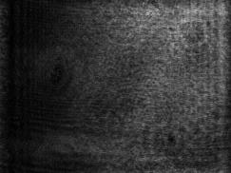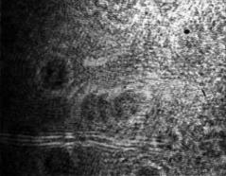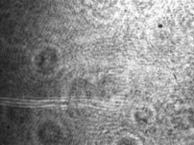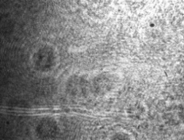
a
b
c
d
Fig. 9. Digital holography imaging for identifying defects in solar cells, visual inspection, or basic threshold-based segmentation. (a) Raw Hologram image (b) Reconstructed holographic image, identifying point of defect (c) Amplitude image, identifying defect point (d) Phase image, locating the defect size.
The CNN effectively identified defect zones, particularly highlighting a significant region arbitrary to Figs. 9, and [30, 40], where the surface exhibited pronounced roughness. This defect was quantified to occupy approximately 9.26% and 4.25% of the total image area. The defect regions were visually represented by red bounding boxes in the detection overlay, offering a clear distinction between affected and unaffected areas. This highlights roughly 90.74% and 95.75% of the two images surfaces were classified as defect-free, marked in green as the output image.
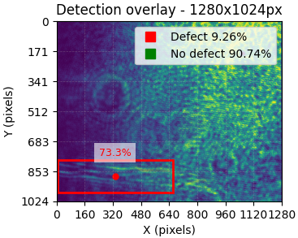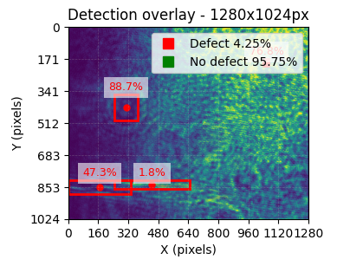
b
a
Fig.10. Fault region label by network of reconstructed image: (a) Roughness defect label with 9.26% (b) Roughness Defect label 4.25%.

A 3D graph was generated to visualize the spatial distribution of surface defects across the photovoltaic module. The implementation utilized OpenCV for image processing and Google Colab as the computational platform, following the architecture outlined in references [32–42]. In this visualization, red points indicate regions where surface roughness was detected, with a noticeable clustering of defects along one edge of the sample. However, the binary bar charts in Fig. 11 provide a quantitative comparison between defective and non-defective regions, clearly illustrating the proportion of surface area affected by imperfections.
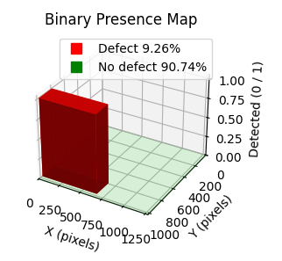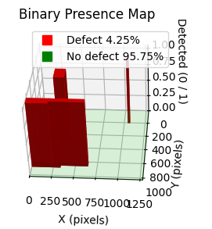
b
a
Fig. 11. 3D view of binary bar chart visualized defect and no defect areas: (a) & (b)

This visualization illustrates the spatial distribution of surface irregularities, with red points indicating areas where roughness was detected, consistent with the roughness findings reported in [35-37] and [30]. Thus, the visualization approach provides a more intuitive understanding of the defect distribution by quantifying surface irregularities as percentages. The results suggest that solar cells maintain a high level of structural integrity, with only a small portion of the area showing signs of degradation or fault.

3.2 Comparison with Conventional Algorithms
The findings presented here reinforce the value of digital holography as a precise, non-contact diagnostic tool. Unlike traditional algorithm-based approaches that rely solely on reconstruction, phase, and amplitude data as in [30-37], the approach does not provide automated classification, subject to inconsistencies, especially when defects are subtle. In contrast, a Deep learning-based network output automatically identifies and highlights defective regions with clear overlays. Precisely, quantifies defect areas values 9.26% and 4.25%, while reporting 90.74% and 95.75% as defect-free areas. These visual outputs not only pinpoint the defective locations but also offer an immediate understanding of their extent. The inclusion of annotated overlays, binary bar charts, and 3D spatial mappings adds a layer of interpretability, strengthening confidence in the model’s predictions, delivering faster, accurate, and quantifiable results compared to the method in [30-37], which illustrates how surface roughness forms and is identified. The capabilities of the Nanovea profilometry HS2000 with a High-Speed Sensor were proved by another solar testing firm, evaluating the geometric features and surface roughness of a photovoltaic cell in [37- 42]. Its strength lies in automated segmentation with high spatial resolution, making it an ideal tool for objective and scalable PV surface inspection.

3.2 Impact of Surface Roughness on Photovoltaic Module Performance
Three-dimensional visualization is essential for evaluating the structural integrity of photovoltaic materials and improving production efficiency. Surface defects, particularly roughness, can degrade optical performance by scattering incoming light, contribute to mechanical stress, and electrical inefficiencies [31-38, 45]. They can also reduce the amount of light that reaches the active layer of the solar cell, decreasing its overall efficiency and lifespan. However, these effects not only reduce overall performance but also compromise the long-term reliability of photovoltaic cells, leading to uneven contact between layers and, in turn, lowering current collection efficiency [31-40]. Moreover, these imperfections may trap dust, airborne contaminants, and potential micro-cracks, which further degrade performance and life span over time [32-37, 45]. Such insights highlight the broader implications of surface defects beyond visual inspection alone.

4.0 Conclusion
This study presents a deep learning-based method for identifying and classifying surface defects in solar cells using digital holographic imaging. A convolutional neural network (CNN) based on the YOLOv8 architecture was employed due to its strong precision and effectiveness in real-time object detection tasks. A dataset was used to train the model, manually annotated reconstructed images, with additional diversity, and rotation performed using the Roboflow platform. The model was incorporated into an automated analysis workflow designed to identify common surface issues. Roughness being specifically detected in the analysis, we examined how surface roughness affects the performance of solar cells under various conditions. Moreover, the rapid, scalable, and consistent inspection techniques that minimize reliance on manual interpretation provide a reliable and non-invasive solution for evaluating photovoltaic surfaces, thereby improving diagnostic accuracy and inspection efficiency in both laboratory and industrial solar cell testing environments.

Acknowledgment
This research was financially supported by the School of Science, King Mongkut’s Institute of Technology, Ladkrabang (Grand No. RA/TA-2024-D-01).

Data Availability
The newly created data is available for reasonable requests and not to be shared with the public.
Conflicts of Interest: The Authors declare no conflicts of interest.
References
- Mantel, C., Villebro, F., dos Reis Benatto, et al., “Machine learning prediction of defect types for electroluminescence images of photovoltaic panels,” SPIE 11139, 1113904 (2019).
- Zeng, Tianjjiao, Yanmin Zhu, and Edmund Y. Lam. “Deep learning for digital holography: a review,” Optics Express. 29(24), 4050472-40593 (2021).
- Ian Goodfellow, Yoshua Bengio, and Aaron Courville. “Regularization for deep learning.” Deep learning. 216-261 (2016).
- Huadong Zheng, Jianbin Hu, Chaojun Zhou et al., “Computing 3D Phase-Type Holograms Based on Deep Learning Method”, photonic. 80070280 (8), 280 (2021).
- Pandey, Dhruvam, and Rajshekhar Gannavarpu. “Deep learning assisted state space method for phase derivative estimation in digital holographic interferometry”. Optics Continuum. 3(9) 1765-1779 (2024).
- Qiang Fang, Haiting Xia, Qinghe Song, et al., “Speckle denoising based on deep learning via conditional generative adversarial network in digital holographic interferometry,” 30(12), 20666-20683 (2022)
- Benton, Stepen A., and V. Michael Bove Jr. “Holographic Imaging,” John Willey and Sons, (983), 750-8400 (2008).
- Jorge Mauicio Flores-Moreno, Manuel De la Torre-Ibarra, Maria del Socorro et al., “DHI Contemporary methodologies: A review and rontiers,” 135, 106184 (2020)
- Gabor “Digital Holography,” Noel Lecture, Proc. IEEE 1972, 60 655-68 (1971).
- Mantel, C., Villebro, F., dos Reis Benatto, et al., “Machine learning prediction of defect types for electroluminescence images of photovoltaic panels,” SPIE 11139, 1113904 (2019).
- Gwani Mohammed, Bako Abdullahi, Umar Muhammad Kangiwa, et al., “Design, Fabrication and Testing of a SEPIC DC-DC Converter for Interfacing Solar PV Module,” 8(01), 269-277 (2022).
- Akash Sing Chaudhary and D. K Chaturvedi “Analyzing Defects of Solar Panel under Natural Atmospheric Conditions with Thermal Image Processing,” (6), 10- 21 (2018).
- Furkan, D. Mahmet Emin, M. “Critical factors that affect the efficiency of solar cells: smart grid and renewable energy,” 1, 47-50 (2010).
- Redondo-Plaza, Alberto, Morales-A, J. I., et al., “Passive electroluminescence and Photoluminescence imaging acquisition of photovoltaic modules,” Sensors. 24(5),1539 (2024).
- Martin L., Devid M., Igor Tyukhov, et al., “Reduced real Lifetime of V Panels- Economic consequences,” 259: 229-234 (2023).
- Ancuta, Florin, and Costin Cepisca, “Analysis of PV Panels Faults by Thermography,” Proc. EVER Monaco; 11, 128-134 (2011).
- dos Reis Benatto GA, Chi M, Lancia AA, Riedel N, Jensen OB, et al., “Scaling up laser line photoluminescence imaging for outdoor inspections,” In 35th European Photovoltaic Solar Energy Conference and Exhibition (2018).
- Dos Reis Benatto, G.A., Chi, M., et al., “Photoluminescence imaging induced by laser line scan: Study for outdoor field inspections,” IEEE 7th (WCPEC), (A Joint 45th IEEE PVSC, 28th PVSEC & 34th EU PVSEC), 0395-0399 (2018).
- Dar, A. U., Ahanger, A. et al., “Applications of artificial intelligence and digital holography in biomedical microscopy,” Authorea Preprints. (2023).
- B.R. Master, “Quantitative Phase Imaging cells and Tissue,” Journal of Biomedical Optics, 17(2), 029901 (2012).
- Zhou, W. J., Li, B. Y., et al., “Tip crack imaging on transparent materials by digital holographic microscopy,” Journal of Imaging, 5(10), 80 (2019).
- Javidi, B., Markman, et al., “Sickle cell disease diagnosis based on spatio-temporal cell dynamics analysis using 3D printed shearing digital holographic microscopy,” Optics Express, 26(10), 13614-13627 (2018).
- Y. Wu, A. Ray, Q. Wei, et al., “Deep Learning Enables High-Throughput Analysis of Particle-Aggregation Based Biosensors Imaged Using Holography,” ACS Photonics, 6, 294– 301 (2019).
- LeCun, Y., Bengio, et al., “Deep learning,” Nature. 521(7553), 436-444 (2015).
- Fang Q. Xia H, Zhang M. Guo R, Montresor S, et al., “Speckle denoising based on deep learning via a conditional generative adversarial network in digital holographic interferometry,” 45921324,30(12), 20666-83 (2022).
- Zhang K., W. Zuo, Y. Chen, et al., “Beyond a Gaussian denoiser: Residual learning of deep learning CNN for image denoising,” IEEE Trans, 26(7), 3142-3155 (2017).
- Zheng H, Hu J, Zhou C, et al., “Computing 3D phase-type holograms based on deep learning method,” Photonics MDPI. 8, (7), 280 (2021).
- O'shea, K., & Nash, R. “An introduction to convolutional neural networks,” preprint arXiv. 1511.08458 (2015).
- Y. J. Jo, S. Park, J. H. Jung, et al., “Holographic deep learning for rapid optical screening of anthrax spores,” Science Advances. 3(8), 1–10 (2017).
- Bako, A., Voochaiphum, B., Suchat, S., & Buranasiri, P. “Optimizing indoor digital holography for photovoltaic surface analysis: a novel approach for solar PV testing conditions”, In International Workshop on Thin Films for Electronics, Electro-Optics, Energy, and Sensors SPIE, (13663), (41-48), (2025).
- Schulze, M. A., Hunt, et al., “Semiconductor wafer defect detection using digital holography,” Proc. SPIE 5041,183-193 (2003).
- Carbonell, Jaime G., Ryszard S. Michalski, et al., "An overview of machine learning: Machine learning,” 3-23 (1983).
- Dinh, H. T., & Kim, E. T. “A Lightweight Network Based on YOLOv8 for Improving Detection Performance and the Speed of Thermal Image Processing. Electronics,” 14(4), 783 (2025).
- Redmon, J., Divvala, S., Girshick, et al., “Unified, real-time object detection,” Proc. IEEE 779-788 (2016).
- Scholtz, Lubomir. Ladanyi, Libor. Mullerova, et al., “Influence of Surface Roughness on Optical Characteristics of Multilayer Solar Cells,” Advances in Electrical and Electronic Engineering. 12(6), 631-638 (2014).
- Xavier Herrera-Keejn, Jocelyn Esparza, Pierre Leroux “Surface Roughness and Feature of a Solar Cell,” (2019).
- Haddad Z, Nahoui A, Salmi M, et al., “Effect of dust on the operation of photovoltaic solar panels installed in the Hodna Region-Experimental study,” Journal of Renewable Energies. 26:75-82 (2023).
- Abou Jieb, Y., & Hossain, E.” Photovoltaic Systems,” Springer. 193-242 (2022).
- Wang, G.” Technology, manufacturing and grid connection of photovoltaic solar cells”. John Wiley & Sons (2018).
- Wang, Z., Liu, Y., Gao, et al., “Environmental impact assessment of the manufacture and use of N-type and P-type photovoltaic modules in China,” Journal of Cleaner Production. 470, 143187 (2024).
- Srivastava, S., Divekar, A. V., et al., “Comparative analysis of deep learning image detection algorithms,”. Journal of Big Data, 8(1), 66(2021).
- Sharma, T., Debaque, B., et al., “Deep learning-based object detection and scene perception under bad weather conditions,” Electronics, 11(4), 563(2022).
- Usman A, Bhatranand A, Buranasiri P. et al., “Phase-shifting determination and pattern recognition using a modified Sagnac interferometer with multiple reflections,” Applied Optics. 63(4),1135-43 (2024).
- Høiaas, I., Grujic, K., Imenes, A. G., Burud, I., Olsen, E., & Belbachir, N. “Inspection and condition monitoring of large-scale photovoltaic power plants: A review of imaging technologies”. Renewable and Sustainable Energy Reviews, 161, 112353 (2022).
- Ružbarský, J. “Roughness control of surfaces using a laser profilometer with the selected material cutting technology”. Materials, 16(11), 4109 (2023).

